Module 7 Assignment Solution
The assignment for Module 7 provides practice using the Crow’s Foot notation. You should use the ER Assistant or other drawing tool to complete the problems in module 7. If you want to use the ER Assistant, I encourage you to watch the software demonstration about the ER Assistant, available in module 7.
- Create an ERD containing the TestOrder and Specimen entity types and a 1-M relationship from Specimen to TestOrder. For each specimen collected, the database should record a unique SpecNo, SpecArea (vaginal, cervical, or endocervical), and SpecCollMethod (thin prep or sure path). A test order contains a TONo (primary key), TOTestName, TOTestType (HPV, CT/GC, CT, or GC), and TOTestResult (positive, negative, equivocal, or failure). A specimen does not have a test order until a delay, from hours to days. If a test order produces a failure, the specimen is given a new test order and tested again until a non-failure result is obtained. A test order is created for exactly one specimen.
- Augment your ERD from problem 1 with the Supply entity type and an M-N relationship between TestOrder and Supply. Choose a name for the relationship based on your common knowledge of test orders and supplies. A test order can use a collection of supplies (0 or more) and a supply can be used on a collection of test orders (0 or more). The Supply entity type contains SuppNo (primary key), SuppName, SuppLotNo, and SuppQOH.
- Use the M-N equivalence rule to transform the M-N relationship in Problem 2. You should choose appropriate names for the new relationships and entity type.
- For each consistency error in Figure 1, you should identify the consistency rule violated and suggest possible resolutions of the error. The ERD has generic names to help will concentrate on finding diagram errors rather than focusing on the meaning of the diagram
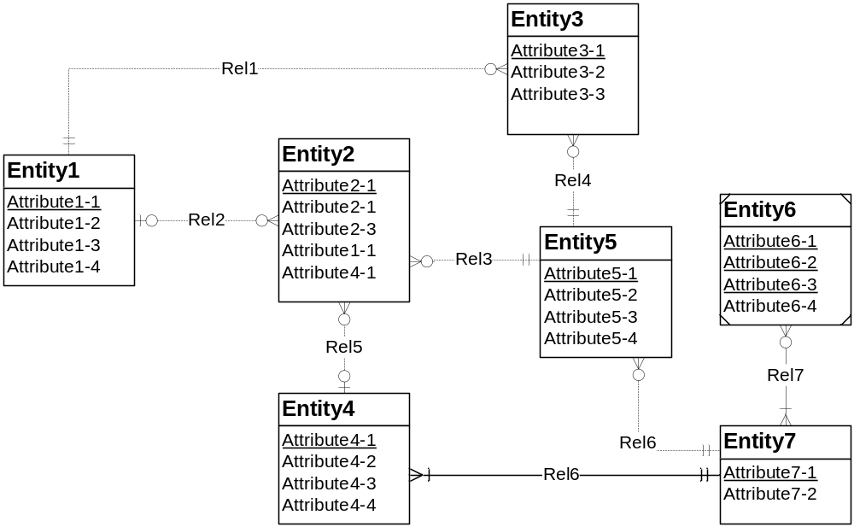
Figure 1: ERD for Problem 4

Solutions
1.
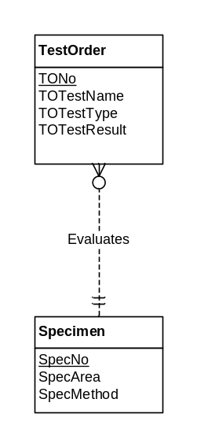
2.
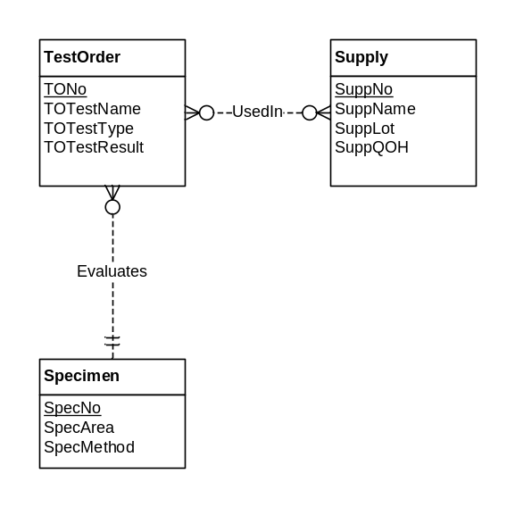
3.
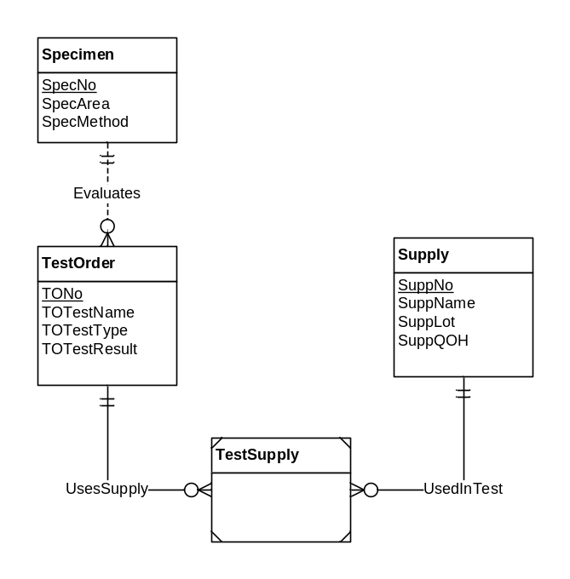
4.
Consistency rule violations are noted on the ERD. Note that there is no violation for identical relationship names.
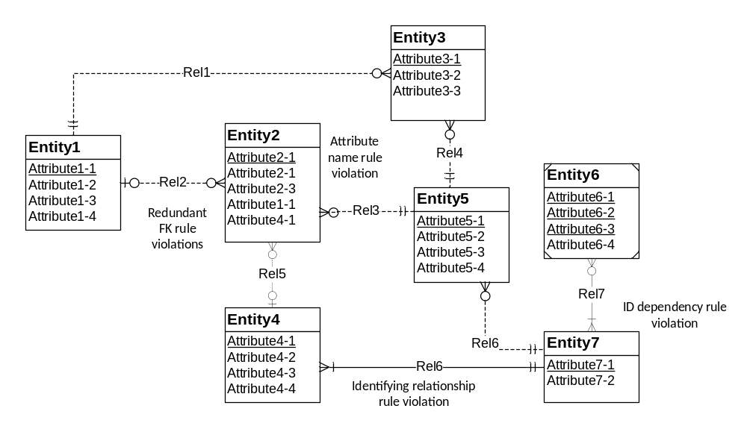
The following list identifies possible ways to fix the consistency errors:
- Attribute name rule resolution: rename one of the Attribute2-1 attributes. Probably renaming the second attribute is easier because it is not the PK.
- Identifying relationship rule resolution: The problem can be resolved by changing Entity4 to a weak entity or changing the relationship (Rel6) to regular (non-identifying).
- Identification dependency cardinality rule resolution: The problem can be resolved by changing the weak entity type’s cardinality in Rel7 (near Entity7) to (1,1). Alternately, Rel7 can be made non-identifying and Entity6 can be changed to strong (non-weak).
- Redundant foreign key rule resolution: Normally the problem can be resolved by removing the redundant foreign keys (Entity2.Attribute1-1 and Entity2.Attribute4-1). If the attributes do not represent foreign keys, they should be renamed instead of removed.

